**REPORT FOR THEORY WITH PRACTICAL**

**\*\*\*\*\*\*HEAD OFFICE MANAGEMENT\*\*\*\*\*\*\***

**SOFTWARE ENGINEERING – CSE18R256**

**Submitted by**

**BUCHUPALLE BAVESH REDDY[ 9918004015]**

Under the guidance of

**Dr. S. DHANASEKARAN, M.E., Ph.D.,**

(Associate Professor, Department of Computer Science and Engineering)

***in partial fulfillment for the award of the degree***

***of***

**BACHELOR OF TECHNOLOGY**

in

**COMPUTER SCIENCE AND ENGINEERING**

***of***



**KALASALINGAM ACADEMY OF RESEARCH AND EDUCATION**

**(Deemed to be University)**

Anand Nagar, Krishnankoil – 626 126

**Academic Year Odd Semester (2020-21)**

**KALASALINGAM ACADEMY OF RESEARCH AND EDUCATION**

**(Deemed to be University)**

Anand Nagar, Krishnankoil – 626 126



**BONAFIDE CERTIFICATE**

This is to certify that the Theory with Practical Report titled **“*****HEAD OFFICE MANAGEMENT *****”** is a bonafide record of the work done by ***** **BUCHUPALLE BAVESH REDDY** ****** **(**9918004015******)** in partial fulfillment of the requirements for the award of the degree of Bachelor of Technology in Specialization of the Computer Science and Engineering, during the Academic year Odd Semester (2020-2021).

**Dr.S.DHANASEKARAN, M.E. Ph.D., Dr.FRANCIS DEVARAJ, M.E., Ph.D.,**

Associate Professor & Supervisor Professor & Head

Department of CSE Department of CSE

**Submitted for the University Viva Voce Examination held on _____________**

**Internal Examiner External Examiner**

**ACKNOWLEDGEMENT**

First and foremost, I wish to thank the **Almighty God** for his grace and benediction to complete this Project work successfully. I would like to convey my special thanks from the bottom of my heart to my dear **Parents** and affectionate **Family members** for their honest support for the completion of this Project work.

I express deep sense of gratitude to “Kalvivallal” Thiru. **T. Kalasalingam** B.com., Founder Chairman, “Ilayavallal” **Dr.K.Sridharan** Ph.D., Chancellor, **Dr.S.ShasiAnanth**, Ph.D., Vice President (Academic) , **Mr.S.Arjun Kalasalingam** M.S., Vice President (Administration) , **Dr.S.Saravanasankar** Ph.D., Vice-Chancellor, **Dr.V.Vasudevan** Ph.D., Registrar , **Dr.P.Deepalakshmi** M.E., Ph.D., Dean (School of Computing) . And also a special thanks to **Dr.Francis Devaraj** M.E., Ph.D., Professor & Head , Department of CSE, Kalasalingam Academy of Research and Education for granting the permission and providing necessary facilities to carry out Project work.

I would like to express my special appreciation and profound thanks to my enthusiastic Project Supervisor **Dr.S.Dhanasekaran** M.E., Ph.D., Associate Professor/ CSEof Kalasalingam Academy of Research and Education [KARE] for his inspiring guidance, constant encouragement with my work during all stages. I am extremely glad that I had a chance to do my Project under my Guide, who truly practices and appreciates deep thinking. I will be forever indebted to my Guide for all the time he has spent with me in discussions. And during the most difficult times when writing this report, he gave me the moral support and the freedom I needed to move on.

Besides my Project guide, I would like to thank the rest of Class committee members and all faculty members and Non-Teaching staff for their insightful comments and encouragement. Finally, but by no means least, thanks go to all my school and college teachers, well wishers, friends for almost unbelievable support.

**INDEX PAGE**

|  |
| --- |
| ABSTRACT |
| ****INTRODUCTION**** |
| OBJECTIVES |
| MATERIAL AND METHODS |
| PROGRAM |
| REQUIRED OUTPUT |
| **COCLUSION** |

## Abstract

Using a network to manage enterprise office affairs is an important means of improving efficiency of the office management and achieving standardization for the enterprise business. The major technology about using c++ to develop an enterprise Head office management system was illustrated in this paper. The contents including the realization of functional modules were discussed, such as: The foreground web page module used by employees, student management module, design of the database tables and web management technology of administrator. The system has features of full-featured, high-efficiency, advanced technology. The systems provide an important reference platform to help enterprise reduce management costs, improve internal management, and enhance competition in the market for comprehensive competitive

## INTRODUCTION

**Head Office management** is a profession involving the design, implementation, evaluation, and maintenance of the process of [work](https://en.wikipedia.org/wiki/Wage_labour) within an [office](https://en.wikipedia.org/wiki/Office) or other organization, in order to sustain and improve [efficiency](https://en.wikipedia.org/wiki/Efficiency) and [productivity](https://en.wikipedia.org/wiki/Productivity).

Office management is thus a part of the overall administration of business and since the elements of management are forecasting and planning, organising, command, control and coordination, the office is a part of the total management function.

Office management is the technique of planning, organizing, coordinating and controlling office activities with a view to achieve business objectives and is concerned with efficient and effective performance of the office work. The success of a business depends upon the efficiency of its office. The volume of paper work in offices has increased manifold in these days due to industrialization, population explosion, government control and application of various tax and labour laws to any business enterprise. Efficiency and effectiveness which are key words in management are achieved only through proper planning and control of activities, reduction of office costs and coordination of all activities of business.

“Office management can be defined as a task of planning, coordination, motivating the efforts of others towards the specific objectives in the office.”

“Office management, as a function, is that branch of the art and science of management which is concerned with efficient performance of office work whenever and wherever that work is to be done.” — William If. Leffingwell and Edwin M. Rot.

“Office management is manipulation and control of men, methods, machine and material to achieve the best possible results-results of highest possible quality with the expenditure of least possible effect and expense, in the shortest practicable time, and in a manner acceptable to the top management.”— Harry H. Wylie.

This definition stresses the utilization of resources of business like material, methods etc. to achieve the objectives and results in a best and cheapest way and in a minimum possible time.

“Office management is the art of guiding the personnel of the office in the use of means appropriate to its environment in order to achieve its specified purpose.”— Mills and Standinhford.

According to this definition, a proper understanding of the objective purpose is necessary so that all efforts and activities are directed in its achievement Environment where office work is to be performed is provided by management after proper planning. Environment means surroundings where employees of an enterprise operate. It includes physical factors like location, layout, lighting temperature, ventilation, cleanliness etc. Various business laws, customs practices etc. must also be made known to employees.

In this definition, author has treated office management as an art of guiding and directing personal or employees in the organization in the use of various means such as machines equipment, office forms, manual, methods etc. The definition stresses the development of persons in the office and not direction of things. Office management must understand the behaviour and needs of his employee so as to motivate him to work by influencing him and by providing incentives so that objective of the organization is achieved.

In simple words, office management can be defined as “a distinct process of planning, organizing, staffing, directing, coordinating and controlling office in order to facilitate achievement of objectives of any business enterprise’ the definition shows managerial functions of an administrative manager. Following diagram indicates various elements or functions in the process of office management.



## Importance of Head Office Management[[edit](https://en.wikipedia.org/w/index.php?title=Office_management&action=edit&section=1" \o "Edit section: Importance of Office Management)]

**The following point enlightens the importance of office management:**

### (i) Helps in Achievement of Targets[[edit](https://en.wikipedia.org/w/index.php?title=Office_management&action=edit&section=2" \o "Edit section: (i) Helps in Achievement of Targets)]

Targets or goals are results in quantitative terms which are to be achieved in a given time. Management makes people realize the goals and directs their efforts towards the achievement of these goals.

### (ii) Optimum Use of Resources[[edit](https://en.wikipedia.org/w/index.php?title=Office_management&action=edit&section=3" \o "Edit section: (ii) Optimum Use of Resources)]

Management helps in utilization of resources effectively. Scarce resources are put to use optimistically by managers. Managers bring about coordination and integration of various resources. It is management which guides the personnel in office in the use of resources.

### (iii) Minimization of Costs[[edit](https://en.wikipedia.org/w/index.php?title=Office_management&action=edit&section=4" \o "Edit section: (iii) Minimization of Costs)]

Office costs can only be reduced under the guidance and control of efficient management. Office Management is concerned with doing the office activities in a best and cheapest way. Cost reduction is one of the object of management which can be achieved through work simplification and mechanization. Through better planning, sound organization and effective control, management enables a concern to reduce costs and prepare an enterprise to face cut throat competition.

### (iv) Smooth Flow of Work[[edit](https://en.wikipedia.org/w/index.php?title=Office_management&action=edit&section=5" \o "Edit section: (iv) Smooth Flow of Work)]

Uninterrupted flow of work is only possible if there is proper planning and control. Management ensures efficient and smooth flow of work.

### (v) Helps in Maintaining Office Efficiency[[edit](https://en.wikipedia.org/w/index.php?title=Office_management&action=edit&section=6" \o "Edit section: (v) Helps in Maintaining Office Efficiency)]

Management helps in maintaining efficiency in an office. A manager not only performs and produces results, but also does it in the most efficient manner so as to contribute towards profit generation.

### (vi) Managing Survival and Growth[[edit](https://en.wikipedia.org/w/index.php?title=Office_management&action=edit&section=7" \o "Edit section: (vi) Managing Survival and Growth)]

Management has to play an important role in keeping the organization alive. Change in technology and methods must be anticipated and adapted for survival and growth. It is only management which can do so and moulds the enterprise in such a changing environment.

### (vii) Provides Innovation[[edit](https://en.wikipedia.org/w/index.php?title=Office_management&action=edit&section=8" \o "Edit section: (vii) Provides Innovation)]

Innovation is finding new, different and better method of doing existing work. To plan and manage innovation, management has to play an important role. Suggestions from customers, information from salesmen, close watch on competitor’s activities provide source of innovation.

### (viii) Helps in Retaining Talent and Inculcating Sense of Loyalty in Office Staff[[edit](https://en.wikipedia.org/w/index.php?title=Office_management&action=edit&section=9" \o "Edit section: (viii) Helps in Retaining Talent and Inculcating Sense of Loyalty in Office Staff)]

Efficient management helps in retaining talented and hard working employees by providing them comfortable work environment. Manager must motivate his employees by recognizing and appreciating their talents.

### (ix) Provides Leadership[[edit](https://en.wikipedia.org/w/index.php?title=Office_management&action=edit&section=10" \o "Edit section: (ix) Provides Leadership)]

Management provides leadership by influencing and guiding office personnel. Managers influence his subordinates to work willingly for achieving organizational goals.

### (x) Managing Change[[edit](https://en.wikipedia.org/w/index.php?title=Office_management&action=edit&section=11" \o "Edit section: (x) Managing Change)]

Importance of office management is that it helps in planning the change and introducing it at the right time and in the right manner. Due to change in technology methods, work procedures etc. have to be changed for efficiency and economy. People resist change due to lack of understanding the reasons for change and lack of training in new methods. Management helps in minimizing resistance of people and acts as a change-agent.

### (xi) Maintaining Public Relations[[edit](https://en.wikipedia.org/w/index.php?title=Office_management&action=edit&section=12" \o "Edit section: (xi) Maintaining Public Relations)]

Office management helps in improving public relations and increasing goodwill of an enterprise by dealing with grievances of consumers and general public.

### (xii) Social Benefits[[edit](https://en.wikipedia.org/w/index.php?title=Office_management&action=edit&section=13" \o "Edit section: (xii) Social Benefits)]

Management is beneficial not only to the business enterprises but to the various segments of society also. It provides and maintains link with various types of suppliers, banks, insurance companies, government departments, and general public. It benefits society as a whole by providing its services.

## OBJECTIVES

The primary goals of an administration manager are to direct, control and supervise the support services of the organization to facilitate its success. The manager achieves this goal by ensuring free flow of **communication** and efficient use of resources throughout the organization.

## Functional Efficiency

The hallmark of a successful administration manager is an operationally and functionally efficient organization. An administrative manager is responsible for coordinating the work of various organizational functions. He organizes meetings and conferences, keeps records and engages in the collection, publishing and dissemination of information to relevant stakeholders including employees, managers and suppliers. An effective administration manager also has a challenge to oversee the proper implementation of organization policies through enforcement of rules and regulations on timekeeping, security, access and even meeting of deadlines.

## Organizational Planning

A competent administration manager is invaluable to organizational planning and accountability initiatives because he is in touch with the needs of the organization. He supervises the procurement and use of organizational supplies and is best-placed to contribute to discussions and strategy formulation on quality assurance and cost control. The manager works with all the departments in the organizations and responds to inquiries from both within and outside the organization. In this position, he gathers information about how each organizational department functions.

## MATERIALS AND MATHEODS

# Office Management: Procedures and Methods

Article shared by : https://www.yourarticlelibrary.com/wp-content/themes/canvas-child/createimage.php?author=Sanjay%20Kumar&height=20&width=200<="" div="" style="margin: 0px; padding: 0px; border: 0px; outline: 0px; font-size: 16px; vertical-align: bottom; background: transparent; max-width: 100%;">

ADVERTISEMENTS:

A procedure stands between a system and an operation. A system for completing a sale is made up of a network of procedures, one of which is likely to be collection for credit sales; one of the operations in the collection procedure is likely to be that of “aging” accounts receivables to indicate appropriate handling standing for varying periods of time. Procedures bring systems down to the level of actual work operations and individual responsibilities.

#### 1. Decide on the Project for Study:

This step may be thought of as searching the environment for possible improvement—and these are usually not hard to find. Unsatisfactory service to customers, high costs, unsatisfactory personnel or equipment utilization, interruptions in work flow, inadequate forms and reports, duplicate effort, and some particular part of the work’ which is repetitive, high in volume, bottlenecked, or monotonous—these, are some clues which indicate the need for systems analysis.

ADVERTISEMENTS:

Conversion to a now data- processing system, reorganization, or other new developments may also signal the need for systems changes. A need may be observed and a study initiated from several sources, as noted previously: departments needing help, higher management, and the systems staff itself, line personnel who wish to undertake study projects, or others.

#### 2. Describe Present System:

The description may be a narrative, chart, measurement data, or other form, or a combination. Charting is especially useful, and will be studied further; a well-adapted chart can help the analyst in visualizing relationships and improvement opportunities, and also those who would be affected by any proposed change.

A variety of methods of gathering information may be employed—a study of information in performance summaries or other documents already available, interviews, observation,’ Work sampling, and other means appropriate to the problem.

#### 3. Analyse and Improve the Present System:

This important step will first require determination of criteria for appraising the former system and any proposed improvement maximum volume, time required quality, costs, crucial features of service in satisfying customer demand, etc. Then, actual data obtained from the description of the present system must be carefully studied.

In addition to direct measures of performance factors, such as those just indicated, checklists of principles regarding factors influencing less than satisfactory results are very often helpful. One person or small group may do much of the spadework during this stage, but before its completion the joint thinking of representative persons involved or affected is almost certain to be helpful.

#### 4. Sell and Install Improved System:

No matter how brilliantly conceived a system is, acceptance by persons affected will go far toward making it work successfully. The best tools for winning acceptance are communication and participation, in most cases. Particularly valuable in methods and higher-level systems improvements will be the participation and personal involvement of those affected by any proposed change. Thorough, two-way communication is also essential for understanding needs, purposes, effects upon individuals, assurances that personal interests will be protected, and knowledge of how the new plan will operate.

ADVERTISEMENTS:

Here is an area where recognition of the staff role filled by analysts is particularly important; they must win rather than demand acceptance, and they must be willing to temper their own judgments and recommendations in, terms of the reactions of affected operating, personnel. Installation of a now procedure or method will often require much care in training personnel in the new approach, making physical changes called for, an following up carefully to see that plans are working out.

#### 5. Maintain and Audit the System:

Failures or shortcomings in procedures and methods will often come to light in the process of carrying on operations, but this cannot be taken for granted. Periodic analyses of the system and its continued adequacy are generally desirable. Some managements schedule such checks’ at definite intervals, varying with the nature of the system and the results obtained from it.

### ****Procedures for Improvement Studies:****

To develop specific improvements, each work step should be examined critically in the light of the different motion principles which may apply to it. The best type of improvement may lie in combining, re-arranging, or simplifying steps that must retained.

Procedures improvement studies, since they often cut across departments, are often initiated by higher management or by the procedures staff, although the need may be suggested by operating personnel involved in a procedure not functioning effectively. Any of the inadequacies suggested in the general approach may suggest the need for such a study. Major steps in the procedure studied must be broken down and recorded in various forms, ranging from a simple list to an elaborate chart probably the most widely used tool of procedures analysis is a flow process chart.

In using the process chart, first, all steps involved in the present procedure are listed in sequence; each step is then classified as an operation, transportation, etc. by using the appropriate symbol shown below. The symbols for each of the steps are inked by lines drawn by the analyst; this results in a graphical representation of the procedure.

**(i) Operation:**

ADVERTISEMENTS:

A large circle denotes that is being changed, added to, or created.

**(ii) Transportation:**

An arrow indicates movement from one place to another.

**(iii) Inspection:**

A square denotes an inspection, as when something is checked or verified but not changed.

**(iv) Delay:**

ADVERTISEMENTS:

A large D indicates an interruption or delay in the flow of the subject being studied,

**(v) Storage:**

An inverted triangle denotes the storage of an object, as when it is protected against unauthorized removal. The flow process chart shows the time required to perform each step; in some instances, only delay steps are timed, to point up opportunities for reducing interruptions in work flow; it also shows the distance in feet whenever transportation is involved. The time and distance features of the chart are particularly useful in appraising layout of equipment and where arrangements might cut down on movements and necessary delays, but they also serve other purposes.

Vertical columns may show departments which handle each portion of the procedure. The flow diagram represents yet another basic analysis tool of the procedures analyst. This diagram is nothing more than the application of a flow chart to a floor Plan of that part of the office involved in the procedure being studied. Its primary purpose is to reveal deficiencies in the present or proposed layout or office arrangement.

#### Selecting the Project for Study:

Even a one-time operation may justify some use of organised common sense, as methods analysis is sometimes called. Benefits expected must be weighed against effort and costs likely to be required. Particularly high returns may result from study of repetitive, high-volume operations because small savings multiplied will add up to substantial amounts. Bottleneck operations may be improved to the point where work flows smoothly and with fewer delays. Monotonous or fatiguing operations may warrant special attention; some methods programmes make the reduction of fatigue their primary objective.

## PROGRAM

IN CPP

Program:

#include<iostream>

using namespace std;

int main() {

int x ;

cout<<"...............................................................................................................\n";

cout<<" HEAD OFFICE MANAGEMENT ";

cout<<"............................................................................................................................................\n";

cout<<"WELCOME TO OUR KALASALINGAM ACADEMIC SCIENCE AND EDUCATION 'head of details of faculties and students' \n";

cout<<"............................................................................................................................................\n";

cout<<"1.give number'1'for faculty information \n";

cout<<"2.give number'2'for students details \n";

/*fAc*/

cin>>x;

switch (x)

{

case 1:

cout <<"Welcome to Kalasalingam faculty information portal \n";

cout<<"select the department \n";

cout<<"................................................................................................................................\n";

cout<<"1.give number '1' to select cse department \n";

cout<<"2.give number '2' to select ece department \n";

cout<<"3.give number '3' to select mec department \n";

cout<<"4.give number '4' to select eee department\n";

cout<<"5.give number '5' to select civil department\n";

//fac information

cin>>x;

switch (x)

{

case 1:

cout<<"welcome to \t** C S E **\t department faculty portal\n";

cout <<"HOD : Bavesh \n";

cout<<"DEAN : Hemanth\n";

cout<<"asst hod: Arshad \n";

cout<<".....................................................................................................................\n";

// cse fac

cout<<"give number '1' for hod,dean,asst hod information \n";

cout<<"give number '2'for profissors information\n";

cout<<"give number'3' for assisstant professors information \n";

cin>>x;

switch (x)

{

case 1:

// cse head

cout<<" sno \t Name \t designation \t salary \n";

cout<<"...... \t .............. \t .................\t .......................\n";

cout<<" 1 \t Bavesh \t HOD \t 150000 \n";

cout<<" 2 \t HEMANTH \t DEAN \t 89000 \n";

cout<<" 3 \t ARSHAD \t ASSISTANT HOD \t 80000 \n";

cout<<"........ * EXIT *............... *EXIT *............... ................ .......................\n";

break;

// cse profissors

case 2:

cout<<"cse department profissors";

cout<<" sno \t Name \t designation \t salary \n";

cout<<"...... \t .............. \t .................\t .......................\n";

cout<<" 1 \t sandhya \t profissor \t 54000 \n";

cout<<" 2 \t abitha \t profissor \t 50000 \n";

cout<<" 3 \t prakhash \t profissor \t 47000 \n";

cout<<" 4 \t siri \t profissor \t 54000 \n";

cout<<" 5 \t mahathma \t profissor \t 50000 \n";

cout<<" 6 \t suresh \t profissor \t 47000 \n";

cout<<"........ *EXIT*............... * EXIT *............... ................ .......................\n";

break;

// cse asst profissors

case 3:

cout<<"cse department assistant profissors";

cout<<" sno \t Name \t designation \t salary \n";

cout<<"...... \t .............. \t ................. \t .......................\n";

cout<<" 4 \t niri \t assisstant profissor \t 54000 \n";

cout<<" 5 \t athma \t assisstant profissor \t 50000 \n";

cout<<" 3 \t rakhesh \t assisstant profissor \t 47000 \n";

cout<<" 1 \t sandilya \t assisstant profissor \t 41000 \n";

cout<<" 2 \t arha \t assisstant profissor \t 38000 \n";

cout<<" 6 \t Ramesh \t assisstant profissor \t 47000 \n";

cout<<"........ *EXIT*............... * EXIT *............... ................ .......................\n";

break;

default:

cout << "Choiced other than 1, 2 and 3 press enter and run again";

break;

}

return 0;

// ece fac

case 2:

cout<<"welcome to \t* E C E **\t department faculty portal\n";

cout <<"HOD : Rama \n";

cout<<"DEAN : salone \n";

cout<<"asst hod: Ravi \n";

cout<<".....................................................................................................................\n";

// ece fac

cout<<"give number '1' for hod,dean,asst hod information \n";

cout<<"give number '2'for profissors information \n";

cout<<"give number'3' for assisstant professors information \n";

cin>>x;

switch (x)

{

case 1:

// ece head

cout<<" sno \t Name \t designation \t salary \n";

cout<<"...... \t .............. \t .................\t .......................\n";

cout<<" 1 \t Rama \t HOD \t 150000 \n";

cout<<" 2 \t Salnre \t DEAN \t 89000 \n";

cout<<" 3 \t Ravi \t ASSISTANT HOD \t 80000 \n";

cout<<"........ * EXIT *............... *EXIT *............... ................ .......................\n";

break;

// ece profissors

case 2:

cout<<"ece department profissors";

cout<<" sno \t Name \t designation \t salary \n";

cout<<"...... \t .............. \t .................\t .......................\n";

cout<<" 1 \t sandhya \t profissor \t 54000 \n";

cout<<" 2 \t abitha \t profissor \t 50000 \n";

cout<<" 3 \t prakhash \t profissor \t 47000 \n";

cout<<" 4 \t siri \t profissor \t 54000 \n";

cout<<" 5 \t mahathma \t profissor \t 50000 \n";

cout<<" 6 \t suresh \t profissor \t 47000 \n";

cout<<"........ *EXIT*............... * EXIT *............... ................ .......................\n";

break;

case 3:

cout<<"ECE department assistant profissors";

cout<<" sno \t Name \t designation \t salary \n";

cout<<"...... \t .............. \t ................. \t .......................\n";

cout<<" 4 \t niri \t assisstant profissor \t 54000 \n";

cout<<" 5 \t athma \t assisstant profissor \t 50000 \n";

cout<<" 3 \t rakhesh \t assisstant profissor \t 47000 \n";

cout<<" 1 \t sandilya \t assisstant profissor \t 41000 \n";

cout<<" 2 \t arha \t assisstant profissor \t 38000 \n";

cout<<" 6 \t Ramesh \t assisstant profissor \t 47000 \n";

cout<<"........ *EXIT*............... * EXIT *............... ................ .......................\n";

break;

default:

cout << "Choiced other than 1, 2 and 3 press enter and run again ";

break;

}

return 0;

case 3:

cout<<"welcome to \t* M E C H **\t department faculty portal\n";

cout <<"HOD : suresh \n";

cout<<"DEAN : ramesh \n";

cout<<"asst hod: somesh \n";

cout<<".....................................................................................................................\n";

// Mech fac

cout<<"give number '1' for hod,dean,asst hod information \n";

cout<<"give number '2' for profissors information \n";

cout<<"give number '3' for assisstant professors information \n";

cin>>x;

switch (x)

{

case 1:

// mech head

cout<<" sno \t Name \t designation \t salary \n";

cout<<"...... \t .............. \t .................\t .......................\n";

cout<<" 1 \t suresh \t HOD \t 150000 \n";

cout<<" 2 \t ramesh \t DEAN \t 89000 \n";

cout<<" 3 \t SOMESH \t ASSISTANT HOD \t 80000 \n";

cout<<"........ * EXIT *............... *EXIT *............... ................ .......................\n";

break;

// mech profissors

case 2:

cout<<"mech department profissors";

cout<<" sno \t Name \t designation \t salary \n";

cout<<"...... \t .............. \t .................\t .......................\n";

cout<<" 4 \t siri \t profissor \t 54000 \n";

cout<<" 5 \t mahathma \t profissor \t 50000 \n";

cout<<" 6 \t suresh \t profissor \t 47000 \n";

cout<<" 3 \t prakhash \t profissor \t 47000 \n";

cout<<" 1 \t sandhya \t profissor \t 54000 \n";

cout<<" 2 \t abitha \t profissor \t 50000 \n";

cout<<"........ *EXIT*............... * EXIT *............... ................ .......................\n";

break;

case 3:

cout<<"mech department assistant profissors";

cout<<" sno \t Name \t designation \t salary \n";

cout<<"...... \t .............. \t ................. \t .......................\n";

cout<<" 3 \t rakhesh \t assisstant profissor \t 47000 \n";

cout<<" 1 \t sandilya \t assisstant profissor \t 41000 \n";

cout<<" 2 \t arha \t assisstant profissor \t 38000 \n";

cout<<" 5 \t athma \t assisstant profissor \t 50000 \n";

cout<<" 6 \t Ramesh \t assisstant profissor \t 47000 \n";

cout<<" 4 \t niri \t assisstant profissor \t 54000 \n";

cout<<"........ *EXIT*............... * EXIT *............... ................ .......................\n";

break;

default:

cout << "Choiced other than 1, 2 and 3 press enter and run again";

break;

}

return 0;

case 4:

cout<<"welcome to \t* E E E **\t department faculty portal\n";

cout <<"HOD : sai \n";

cout<<"DEAN : ms dhoni \n";

cout<<"asst hod: kohli \n";

cout<<".....................................................................................................................\n";

// eee fac

cout<<"give number '1' for hod,dean,asst hod information \n";

cout<<"give number '2' for profissors information \n";

cout<<"give number '3' for assisstant professors information \n";

cin>>x;

switch (x)

{

case 1:

// eee head

cout<<" sno \t Name \t designation \t salary \n";

cout<<"...... \t .............. \t .................\t .......................\n";

cout<<" 1 \t sai \t HOD \t 150000 \n";

cout<<" 2 \t ms dhoni \t DEAN \t 89000 \n";

cout<<" 3 \t kohli \t ASSISTANT HOD \t 80000 \n";

cout<<"........ * EXIT *............... *EXIT *............... ................ .......................\n";

break;

// eee profissors

case 2:

cout<<"eee department profissors";

cout<<" sno \t Name \t designation \t salary \n";

cout<<"...... \t .............. \t .................\t .......................\n";

cout<<" 6 \t suresh \t profissor \t 47000 \n";

cout<<" 2 \t abitha \t profissor \t 50000 \n";

cout<<" 1 \t sandhya \t profissor \t 54000 \n";

cout<<" 3 \t prakhash \t profissor \t 47000 \n";

cout<<" 4 \t siri \t profissor \t 54000 \n";

cout<<" 5 \t mahathma \t profissor \t 50000 \n";

cout<<"........ *EXIT*............... * EXIT *............... ................ .......................\n";

break;

case 3:

cout<<"EEE department assistant profissors";

cout<<" sno \t Name \t designation \t salary \n";

cout<<"...... \t .............. \t ................. \t .......................\n";

cout<<" 2 \t arha \t assisstant profissor \t 38000 \n";

cout<<" 5 \t athma \t assisstant profissor \t 50000 \n";

cout<<" 4 \t niri \t assisstant profissor \t 54000 \n";

cout<<" 3 \t rakhesh \t assisstant profissor \t 47000 \n";

cout<<" 1 \t sandilya \t assisstant profissor \t 41000 \n";

cout<<" 6 \t Ramesh \t assisstant profissor \t 47000 \n";

cout<<"........ *EXIT*............... * EXIT *............... ................ .......................\n";

break;

default:

cout << "Choiced other than 1, 2 and 3 press enter and run again ";

break;

}

return 0;

case 5:

cout<<"welcome to \t* CIVIL **\t department faculty portal\n";

cout <<"HOD : viva \n";

cout<<"DEAN : scoda \n";

cout<<"asst hod: maruthi \n";

cout<<".....................................................................................................................\n";

// civil fac

cout<<"give number '1' for hod,dean,asst hod information \n";

cout<<"give number '2'for profissors information \n";

cout<<"give number'3' for assisstant professors information \n";

cin>>x;

switch (x)

{

case 1:

// civil head

cout<<" sno \t Name \t designation \t salary \n";

cout<<"...... \t .............. \t .................\t .......................\n";

cout<<" 1 \t viva \t HOD \t 150000 \n";

cout<<" 2 \t scoda \t DEAN \t 89000 \n";

cout<<" 3 \t maruthi \t ASSISTANT HOD \t 80000 \n";

cout<<"........ * EXIT *............... *EXIT *............... ................ .......................\n";

break;

// civil profissors

case 2:

cout<<"civil department profissors";

cout<<" sno \t Name \t designation \t salary \n";

cout<<"...... \t .............. \t .................\t .......................\n";

cout<<" 1 \t sandhya \t profissor \t 54000 \n";

cout<<" 2 \t abitha \t profissor \t 50000 \n";

cout<<" 3 \t prakhash \t profissor \t 47000 \n";

cout<<" 4 \t siri \t profissor \t 54000 \n";

cout<<" 5 \t mahathma \t profissor \t 50000 \n";

cout<<" 6 \t suresh \t profissor \t 47000 \n";

cout<<"........ *EXIT*............... * EXIT *............... ................ .......................\n";

break;

case 3:

cout<<"civil department assistant profissors";

cout<<" sno \t Name \t designation \t salary \n";

cout<<"...... \t .............. \t ................. \t .......................\n";

cout<<" 4 \t niri \t assisstant profissor \t 54000 \n";

cout<<" 5 \t athma \t assisstant profissor \t 50000 \n";

cout<<" 3 \t rakhesh \t assisstant profissor \t 47000 \n";

cout<<" 1 \t sandilya \t assisstant profissor \t 41000 \n";

cout<<" 2 \t arha \t assisstant profissor \t 38000 \n";

cout<<" 6 \t Ramesh \t assisstant profissor \t 47000 \n";

cout<<"........ *EXIT*............... * EXIT *............... ................ .......................\n";

break;

default:

cout << "Choiced other than 1, 2 and 3 press enter and run again ";

break;

}

return 0;

default:

cout << "Choiced other than 1, 2, 3,4 and 5 press enter and run again ";

break;

}

return 0;

// student

case 2:

cout<<"..........................STUDENT PORTAL .................................................\n";

cout <<"welcome to students details portal \n";

cout<<"select the department \n";

cout<<"......................................................................................................................\n";

// student sub

cout<<"1.give number '1' to select cse department \n";

cout<<"2.give number '2' to select ece department \n";

cout<<"3.give number '3' to select mec department \n";

cout<<"4.give number '4' to select eee department\n";

cout<<"5.give number '5' to select civil department\n";

cin>>x;

switch (x)

{

// cse student

case 1:

cout<<"welcome to cse department student portal\n";

cout <<"HOD : Bavesh \n";

cout<<"DEAN : hemanth \n";

cout<<"asst hod : Arshad \n";

//cse stud

cout<<".........................CSE DEPARTMENT STUDENTS ..........................................................\n";

cout<<" register number \t Name \t CGPA \t fee/annual \n";

cout<<"................ \t .............. \t .................\t .......................\n";

cout<<" 10001 \t Bavesh \t 8.2 \t 75000 \n";

cout<<" 10002 \t arha \t 9.2 \t 50000 \n";

cout<<" 10003 \t chinta \t 6.42 \t 100000 \n";

cout<<" 10004 \t rahul \t 7.24 \t 100000 \n";

cout<<" 10005 \t shiva \t 8.7 \t 75000 \n";

cout<<" 10006 \t sushanth \t 9.32 \t 50000 \n";

cout<<" 10007 \t Bavesh \t 8.2 \t 75000 \n";

cout<<" 10008 \t Bavesh \t 8.2 \t 75000 \n";

cout<<" 10009 \t Bavesh \t 8.2 \t 75000 \n";

cout<<" 10010 \t Bavesh \t 8.2 \t 75000 \n";

cout<<" 10011 \t Bavesh \t 8.2 \t 75000 \n";

cout<<" 10012 \t Bavesh \t 8.2 \t 75000 \n";

cout<<" 10013 \t Bavesh \t 8.2 \t 75000 \n";

cout<<" 10014 \t Bavesh \t 8.2 \t 75000 \n";

cout<<" 10015 \t Bavesh \t 8.2 \t 75000 \n";

cout<<" 10016 \t Bavesh \t 8.2 \t 75000 \n";

cout<<" 10017 \t Bavesh \t 8.2 \t 75000 \n";

cout<<" 10018 \t Bavesh \t 8.2 \t 75000 \n";

cout<<" 10019 \t Bavesh \t 8.2 \t 75000 \n";

cout<<" 10020 \t Bavesh \t 8.2 \t 75000 \n";

cout<<" 10021 \t Bavesh \t 8.2 \t 75000 \n";

cout<<" 10022 \t Bavesh \t 8.2 \t 75000 \n";

cout<<" 10023 \t Bavesh \t 8.2 \t 75000 \n";

cout<<" 10024 \t Bavesh \t 8.2 \t 75000 \n";

cout<<" 10025 \t Bavesh \t 8.2 \t 75000 \n";

cout<<" 10026 \t Bavesh \t 8.2 \t 75000 \n";

cout<<" 10027 \t Bavesh \t 8.2 \t 75000 \n";

cout<<" 10028 \t Bavesh \t 8.2 \t 75000 \n";

cout<<" 10029 \t Bavesh \t 8.2 \t 75000 \n";

cout<<" 10030 \t Bavesh \t 8.2 \t 75000 \n";

cout<<" 10031 \t Bavesh \t 8.2 \t 75000 \n";

cout<<" 10032 \t Bavesh \t 8.2 \t 75000 \n";

cout<<" 10033 \t Bavesh \t 8.2 \t 75000 \n";

cout<<" 10034 \t Bavesh \t 8.2 \t 75000 \n";

cout<<"........ * EXIT *............... *EXIT *............... ................ ...................\n";

break;

case 2:

cout<<"welcome to \t* E C E **\t department faculty portal\n";

cout <<"HOD : Rama \n";

cout<<"DEAN : salone \n";

cout<<"asst hod: Ravi \n";

cout<<".....................................................................................................................\n";

//ece stud

cout<<".........................ECE DEPARTMENT STUDENTS ..........................................................\n";

cout<<" register number \t Name \t CGPA \t fee/annual \n";

cout<<"................ \t .............. \t .................\t .......................\n";

cout<<" 20001 \t Bavesh \t 8.2 \t 75000 \n";

cout<<" 20002 \t arha \t 9.2 \t 50000 \n";

cout<<" 20003 \t chinta \t 6.42 \t 100000 \n";

cout<<" 20004 \t rahul \t 7.24 \t 100000 \n";

cout<<" 20005 \t shiva \t 8.7 \t 75000 \n";

cout<<" 20006 \t sushanth \t 9.32 \t 50000 \n";

cout<<" 20007 \t Bavesh \t 8.2 \t 75000 \n";

cout<<" 20008 \t Bavesh \t 8.2 \t 75000 \n";

cout<<" 20009 \t Bavesh \t 8.2 \t 75000 \n";

cout<<" 20010 \t Bavesh \t 8.2 \t 75000 \n";

cout<<" 20011 \t Bavesh \t 8.2 \t 75000 \n";

cout<<" 20012 \t Bavesh \t 8.2 \t 75000 \n";

cout<<" 20013 \t Bavesh \t 8.2 \t 75000 \n";

cout<<" 20014 \t Bavesh \t 8.2 \t 75000 \n";

cout<<" 20015 \t Bavesh \t 8.2 \t 75000 \n";

cout<<" 20016 \t Bavesh \t 8.2 \t 75000 \n";

cout<<" 20017 \t Bavesh \t 8.2 \t 75000 \n";

cout<<" 20018 \t Bavesh \t 8.2 \t 75000 \n";

cout<<" 20019 \t Bavesh \t 8.2 \t 75000 \n";

cout<<" 20020 \t Bavesh \t 8.2 \t 75000 \n";

cout<<" 20021 \t Bavesh \t 8.2 \t 75000 \n";

cout<<" 20022 \t Bavesh \t 8.2 \t 75000 \n";

cout<<" 20023 \t Bavesh \t 8.2 \t 75000 \n";

cout<<" 20024 \t Bavesh \t 8.2 \t 75000 \n";

cout<<" 20025 \t Bavesh \t 8.2 \t 75000 \n";

cout<<" 20026 \t Bavesh \t 8.2 \t 75000 \n";

cout<<" 20027 \t Bhgyuf \t 8.2 \t 75000 \n";

cout<<" 20028 \t utufyi \t 8.2 \t 75000 \n";

cout<<" 20029 \t rstrki \t 8.2 \t 75000 \n";

cout<<" 20030 \t kjhhkj \t 8.2 \t 75000 \n";

cout<<" 20031 \t Bavesh \t 5.2 \t 100000 \n";

cout<<" 20032 \t Bavoih \t 7.2 \t 90000 \n";

cout<<" 20033 \t hgjhsh \t 6.2 \t 100000 \n";

cout<<" 20034 \t Byfuyj \t 6.2 \t 100000 \n";

cout<<"........ * EXIT *............... *EXIT *............... ................ .................\n";

break;

case 3:

cout<<"welcome to \t* M E C H **\t department faculty portal\n";

cout <<"HOD : suresh \n";

cout<<"DEAN : ramesh \n";

cout<<"asst hod: somesh \n";

cout<<".....................................................................................................................\n";

//mech stude

cout<<".........................MECH DEPARTMENT STUDENTS ..........................................................\n";

cout<<" register number \t Name \t CGPA \t fee/annual \n";

cout<<"................ \t .............. \t .................\t .......................\n";

cout<<" 30001 \t Bavesh \t 8.2 \t 75000 \n";

cout<<" 30002 \t arha \t 9.2 \t 50000 \n";

cout<<" 30003 \t chinta \t 6.42 \t 100000 \n";

cout<<" 30004 \t rahul \t 7.24 \t 100000 \n";

cout<<" 30005 \t shiva \t 8.7 \t 75000 \n";

cout<<" 30006 \t sushanth \t 9.32 \t 50000 \n";

cout<<" 30007 \t Bavesh \t 8.2 \t 75000 \n";

cout<<" 30008 \t Bavesh \t 8.2 \t 75000 \n";

cout<<" 30009 \t Bavesh \t 8.2 \t 75000 \n";

cout<<" 30010 \t Bavesh \t 8.2 \t 75000 \n";

cout<<" 30011 \t Bavesh \t 8.2 \t 75000 \n";

cout<<" 30012 \t Bavesh \t 8.2 \t 75000 \n";

cout<<" 30013 \t Bavesh \t 8.2 \t 75000 \n";

cout<<" 30014 \t Bavesh \t 8.2 \t 75000 \n";

cout<<" 30015 \t Bavesh \t 8.2 \t 75000 \n";

cout<<" 30016 \t Bavesh \t 8.2 \t 75000 \n";

cout<<" 30017 \t Bavesh \t 8.2 \t 75000 \n";

cout<<" 30018 \t Bavesh \t 8.2 \t 75000 \n";

cout<<" 30019 \t Bavesh \t 8.2 \t 75000 \n";

cout<<" 30020 \t Bavesh \t 8.2 \t 75000 \n";

cout<<" 30021 \t Bavesh \t 8.2 \t 75000 \n";

cout<<" 30022 \t Bavesh \t 8.2 \t 75000 \n";

cout<<" 30023 \t Bavesh \t 8.2 \t 75000 \n";

cout<<" 30024 \t Bavesh \t 8.6 \t 50000 \n";

cout<<" 30025 \t Bavesh \t 8.9 \t 50000 \n";

cout<<" 30026 \t Bavesh \t 8.2 \t 75000 \n";

cout<<" 30027 \t Bavesh \t 8.8 \t 75000 \n";

cout<<" 30028 \t avibgy \t 8.5 \t 75000 \n";

cout<<" 30029 \t Bavesh \t 8.6 \t 75000 \n";

cout<<" 30030 \t giuhkh \t 8.3 \t 75000 \n";

cout<<" 30031 \t Bauihy \t 8.4 \t 75000 \n";

cout<<" 30032 \t Bafutg \t 7.9 \t 90000 \n";

cout<<" 30033 \t tfdyuh \t 6.7 \t 100000 \n";

cout<<" 30034 \t trddht \t 4.5 \t 100000 \n";

cout<<"........ * EXIT *............... *EXIT *............... ................ ................\n";

break;

case 4:

cout<<"welcome to \t* E E E **\t department faculty portal\n";

cout <<"HOD : sai \n";

cout<<"DEAN : ms dhoni \n";

cout<<"asst hod: kohli \n";

cout<<".....................................................................................................................\n";

//EEE Stude

cout<<".........................EEE DEPARTMENT STUDENTS ..........................................................\n";

cout<<" register number \t Name \t CGPA \t fee/annual \n";

cout<<"................ \t .............. \t .................\t .......................\n";

cout<<" 40001 \t Bavesh \t 8.2 \t 75000 \n";

cout<<" 40002 \t arha \t 9.2 \t 50000 \n";

cout<<" 40003 \t chinta \t 6.42 \t 100000 \n";

cout<<" 40004 \t rahul \t 7.24 \t 100000 \n";

cout<<" 40005 \t shiva \t 8.7 \t 75000 \n";

cout<<" 40006 \t sushanth \t 9.32 \t 50000 \n";

cout<<" 40007 \t Bavesh \t 8.2 \t 75000 \n";

cout<<" 40008 \t Bavesh \t 8.2 \t 75000 \n";

cout<<" 40009 \t Bavesh \t 8.2 \t 75000 \n";

cout<<" 40010 \t Bavesh \t 8.2 \t 75000 \n";

cout<<" 40011 \t Bavesh \t 8.2 \t 75000 \n";

cout<<" 40012 \t Bavesh \t 8.2 \t 75000 \n";

cout<<" 40013 \t Bavesh \t 8.2 \t 75000 \n";

cout<<" 40014 \t Bavesh \t 8.2 \t 75000 \n";

cout<<" 40015 \t Bavesh \t 8.2 \t 75000 \n";

cout<<" 40016 \t Bavesh \t 8.2 \t 75000 \n";

cout<<" 40017 \t Bavesh \t 8.2 \t 75000 \n";

cout<<" 40018 \t Bavesh \t 8.2 \t 75000 \n";

cout<<" 40019 \t Bavesh \t 8.2 \t 75000 \n";

cout<<" 40020 \t Bavesh \t 8.2 \t 75000 \n";

cout<<" 40021 \t Bavesh \t 8.2 \t 75000 \n";

cout<<" 40022 \t Bavesh \t 8.2 \t 75000 \n";

cout<<" 40023 \t Bavesh \t 8.2 \t 75000 \n";

cout<<" 40024 \t Bavesh \t 8.2 \t 75000 \n";

cout<<" 40025 \t Bavesh \t 8.2 \t 75000 \n";

cout<<" 40026 \t Bavesh \t 8.2 \t 75000 \n";

cout<<" 40027 \t Bavesh \t 8.2 \t 75000 \n";

cout<<" 40028 \t Bavesh \t 8.2 \t 75000 \n";

cout<<" 40029 \t Bavesh \t 8.2 \t 75000 \n";

cout<<" 40030 \t Bavesh \t 8.2 \t 75000 \n";

cout<<" 40031 \t Bavesh \t 8.2 \t 75000 \n";

cout<<" 40032 \t Bavesh \t 8.2 \t 75000 \n";

cout<<" 40033 \t Bavesh \t 8.2 \t 75000 \n";

cout<<" 40034 \t Bavesh \t 8.2 \t 75000 \n";

cout<<"........ * EXIT *............... *EXIT *............... ................ ..............\n";

break;

case 5:

cout<<"welcome to \t* CIVIL **\t department faculty portal\n";

cout <<"HOD : viva \n";

cout<<"DEAN : scoda \n";

cout<<"asst hod: maruthi \n";

cout<<"............................................................................................\n";

// Civil students

cout<<".........................CIVIL DEPARTMENT STUDENTS ........................................\n";

cout<<" register number \t Name \t CGPA \t fee/annual \n";

cout<<"................ \t .............. \t .................\t .......................\n";

cout<<" 50001 \t Bavesh \t 8.2 \t 75000 \n";

cout<<" 50002 \t arha \t 9.2 \t 50000 \n";

cout<<" 50003 \t chinta \t 6.42 \t 100000 \n";

cout<<" 50004 \t rahul \t 7.24 \t 100000 \n";

cout<<" 50005 \t shiva \t 8.7 \t 75000 \n";

cout<<" 50006 \t sushanth \t 9.32 \t 50000 \n";

cout<<" 50007 \t Bavesh \t 8.2 \t 75000 \n";

cout<<" 50008 \t Bavesh \t 8.2 \t 75000 \n";

cout<<" 50009 \t Bavesh \t 8.2 \t 75000 \n";

cout<<" 50010 \t Bavesh \t 8.2 \t 75000 \n";

cout<<" 50011 \t Bavesh \t 8.2 \t 75000 \n";

cout<<" 50012 \t Bavesh \t 8.2 \t 75000 \n";

cout<<" 50013 \t Bavesh \t 8.2 \t 75000 \n";

cout<<" 50014 \t Bavesh \t 8.2 \t 75000 \n";

cout<<" 50015 \t Bavesh \t 8.2 \t 75000 \n";

cout<<" 50016 \t Bavesh \t 8.2 \t 75000 \n";

cout<<" 50017 \t Bavesh \t 8.2 \t 75000 \n";

cout<<" 50018 \t Bavesh \t 8.2 \t 75000 \n";

cout<<" 50019 \t Bavesh \t 8.2 \t 75000 \n";

cout<<" 50020 \t Bavesh \t 8.2 \t 75000 \n";

cout<<" 50021 \t Bavesh \t 8.2 \t 75000 \n";

cout<<" 50022 \t Bavesh \t 8.2 \t 75000 \n";

cout<<" 50023 \t Bavesh \t 8.2 \t 75000 \n";

cout<<" 50024 \t Bavesh \t 8.2 \t 75000 \n";

cout<<" 50025 \t Bavesh \t 8.2 \t 75000 \n";

cout<<" 50026 \t Bavesh \t 8.2 \t 75000 \n";

cout<<" 50027 \t Bavesh \t 8.2 \t 75000 \n";

cout<<" 50028 \t Bavesh \t 8.2 \t 75000 \n";

cout<<" 50029 \t Bavesh \t 8.2 \t 75000 \n";

cout<<" 50030 \t Bavesh \t 8.2 \t 75000 \n";

cout<<" 50031 \t Bavesh \t 8.2 \t 75000 \n";

cout<<" 50032 \t Bavesh \t 8.2 \t 75000 \n";

cout<<" 50033 \t Bavesh \t 8.2 \t 75000 \n";

cout<<" 50034 \t Bavesh \t 8.2 \t 75000 \n";

cout<<"........ * EXIT *............... *EXIT *............... ................ ...............\n";

break;

cout<<".......................................................................................\n";

cout<<".............................................................................................\n";

default:

cout << "Choiced other than 1, 2, 3,4 and 5 press enter and run again";

break;

}

return 0;

default:

cout << "Choiced other than 1 and 2 press enter and run again";

break;

}

return 0;

}

## REQUIRED OUTPUT

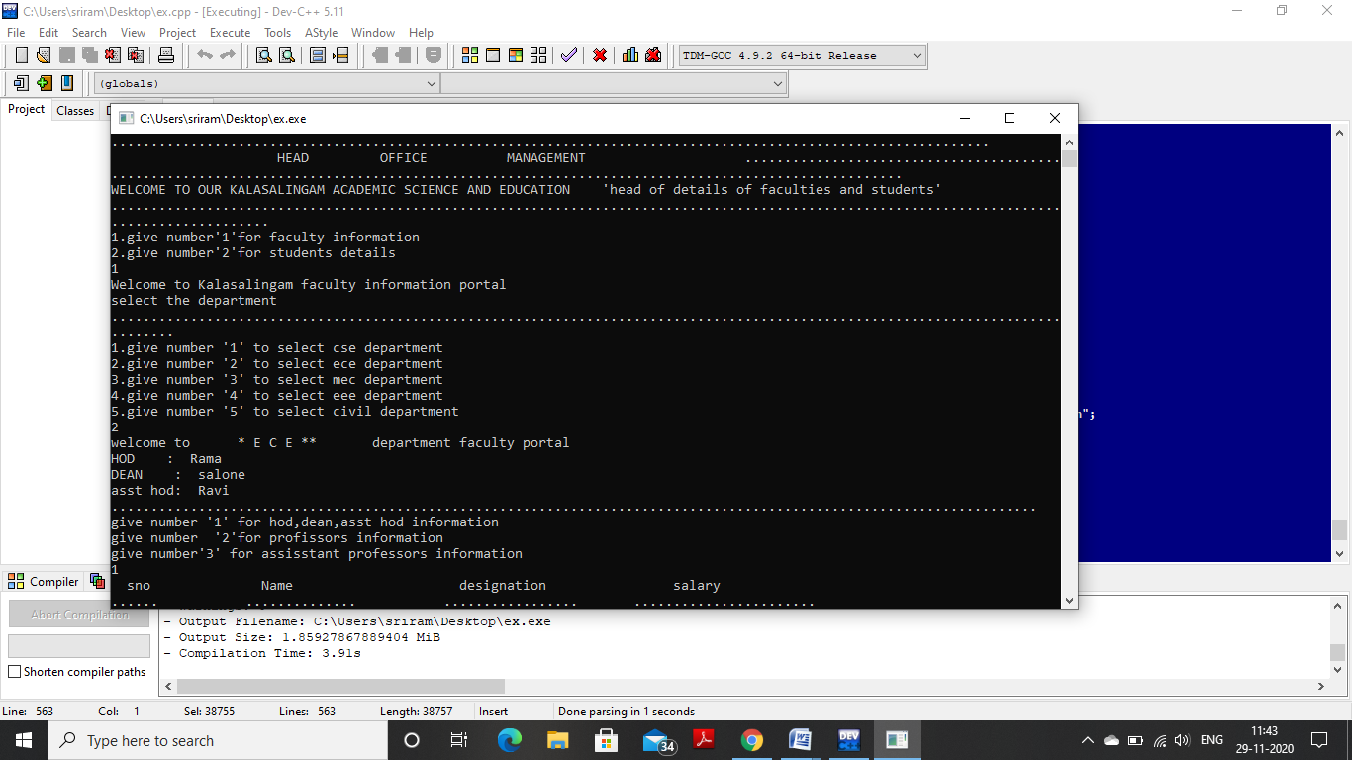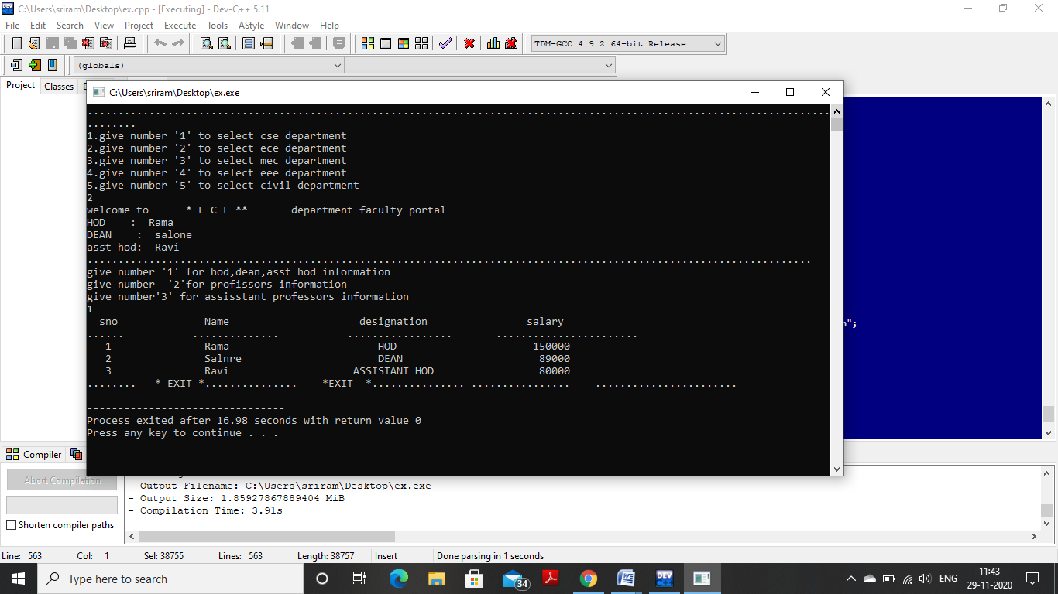

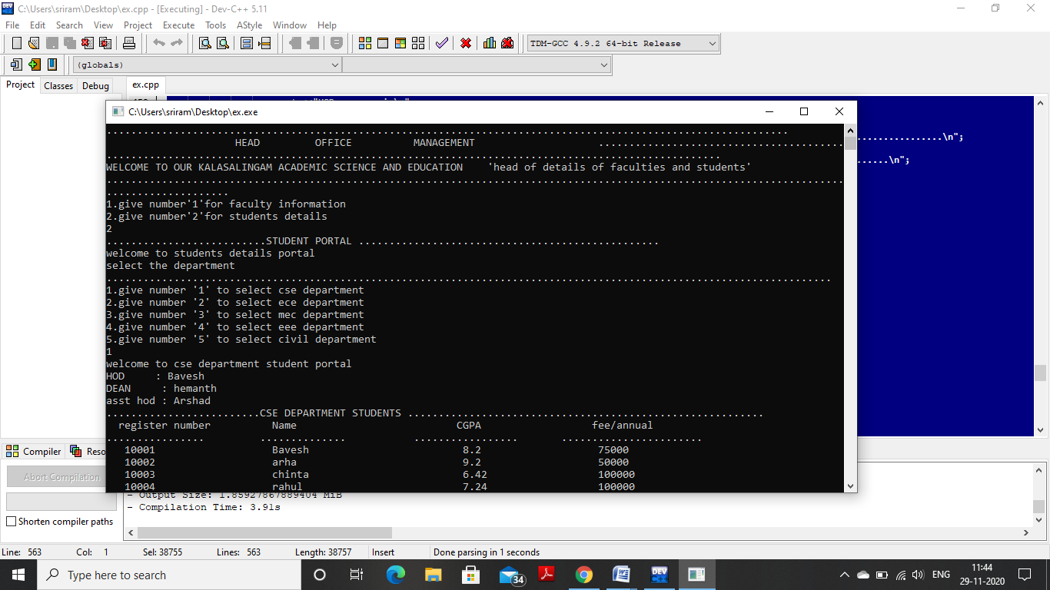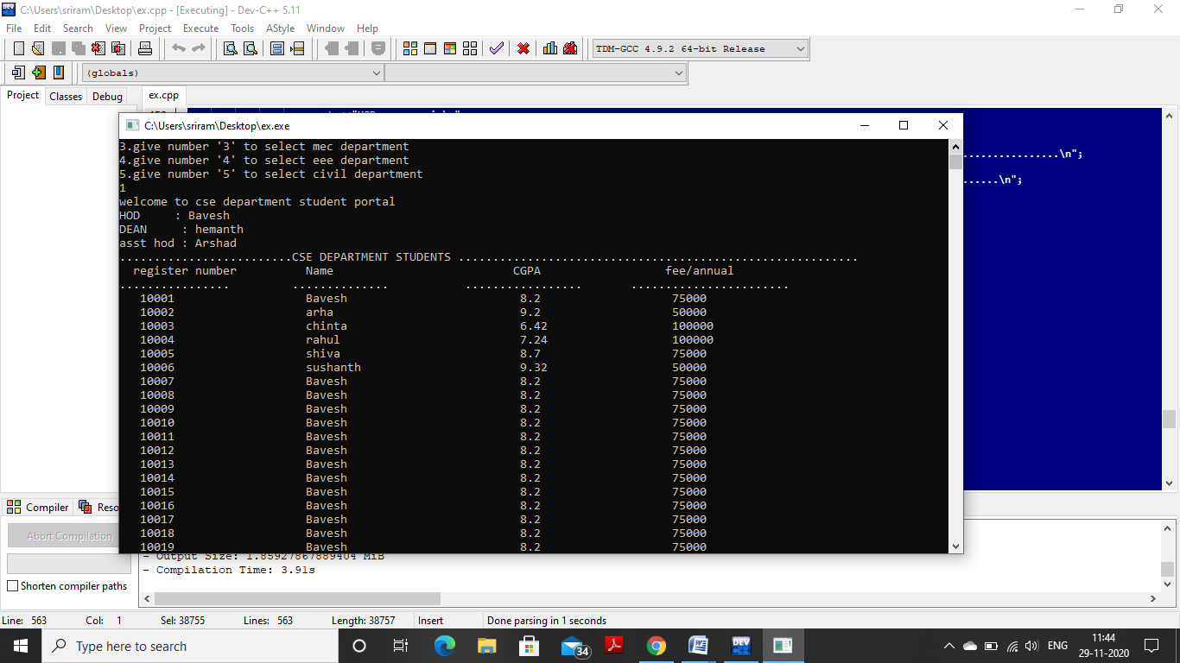

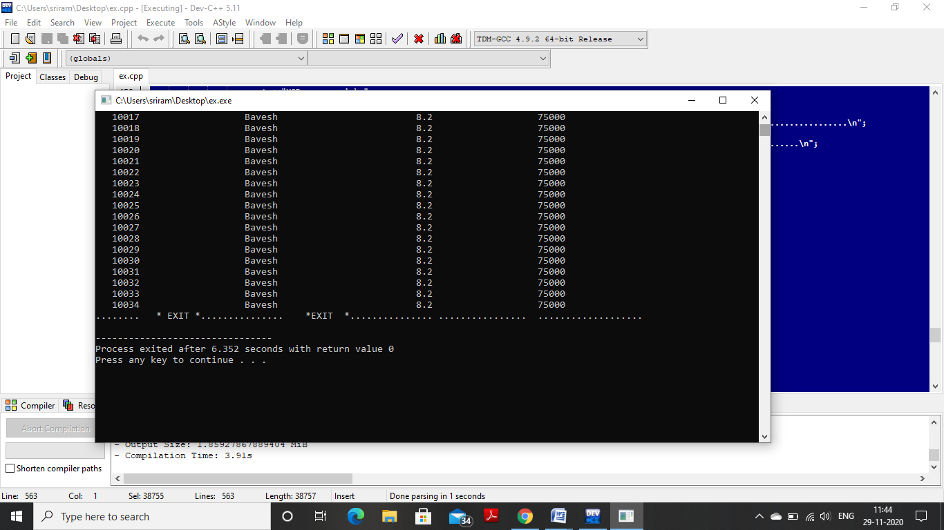

## COCLUSION

An head office manager is responsible for monitoring and reviewing systems, usually focusing on specific outcomes such as improved timescales, turnover, output, sales, etc. They may supervise or manage a team of administrators, allocating roles, recruiting and training, and issuing assignments and projects. As such the role is varied, often including responsibilities across a diverse range of functions such as:

* [Bookkeeping](https://en.wikipedia.org/wiki/Bookkeeping)
* [Business process mapping](https://en.wikipedia.org/wiki/Business_process_mapping)
* [Cost accounting](https://en.wikipedia.org/wiki/Cost_accounting)
* [Customer service](https://en.wikipedia.org/wiki/Customer_service)
* [Database management](https://en.wikipedia.org/wiki/Database_management)
* [Facility management](https://en.wikipedia.org/wiki/Facility_management)
* Design of [form](https://en.wikipedia.org/wiki/Form_(document)) or [document templates](https://en.wikipedia.org/wiki/Document_template)
* [Human resources](https://en.wikipedia.org/wiki/Human_resources)
* [Management information systems](https://en.wikipedia.org/wiki/Management_information_system)
* [Management consulting](https://en.wikipedia.org/wiki/Management_consulting)
* [Occupational safety and health](https://en.wikipedia.org/wiki/Occupational_safety_and_health)
* [Payroll](https://en.wikipedia.org/wiki/Payroll)
* [Project management](https://en.wikipedia.org/wiki/Project_management)
* [Purchasing](https://en.wikipedia.org/wiki/Purchasing)
* [Records management](https://en.wikipedia.org/wiki/Records_management)
* [Recruitment](https://en.wikipedia.org/wiki/Recruitment)
* [Report](https://en.wikipedia.org/wiki/Report) writing
* [Risk management](https://en.wikipedia.org/wiki/Risk_management)
* Sales and marketing
* [Security management](https://en.wikipedia.org/wiki/Security_management)
* Space management
* [Systems analysis](https://en.wikipedia.org/wiki/Systems_analysis)
* Website maintenance